WYLIE ISD PRE-K INCOME VERIFICATION FORM
Name of Student Applying for Pre-K: ________________________________________________
Parent/Guardian Name: ______________________________________________________________
Phone Number: __________________ Email: _________________________________________
Please note that all income sources listed below must be verified by at least one of the following documents: current paycheck stub, current pay envelope, letter from employer stating gross wages and how often they are paid, unemployment/worker's compensation, or disability payment stub. Acceptable documentation for self-employment income includes: business or farming documents, such as ledger books or self-issued paycheck stub, or last year's tax return. Acceptable documentation for cash income is a letter from the employer stating wages paid and frequency. Applicants must submit documents that show income received by the household during the current month. The document ought to contain the name of the person, the amount of income, and the date received. A pay stub with no date will not be sufficient. Reported gross income is any money received on a recurring basis, including gross earned income. Specifically, gross income means all money earned before any deductions, such as income taxes, employee's social security taxes, insurance premiums, bonds, and charitable contributions.
_____________________________________________________________________________
Do any household members (including you) currently participate in SNAP, TANF, and/or FDPIR?
Please choose yes or no: ☐Yes ☐No
If YES to SNAP/TANF, write the Eligibility Determination Group (EDG) number in this space:
(Must be an 8- or 9-digit number) ______________________________________________________

Income Determination: Multiple incomes and frequencies must be converted to one total amount to determine total household income.
Household Size (including children and adults): ________________________________
Total Income: $_______________________________________
☐ Weekly ☐ Every 2 Weeks ☐ Twice a Month ☐ Monthly ☐ Annually
(Annual Income Conversion: Weekly X52 Every 2 weeks X26 Twice a month X24 Monthly X12) _____________________________________________________________________________
I certify (promise) that all information on this form is true and that all income is reported. I understand that this information is given in connection with the receipt of federal funds and that school officials may verify the information. I am aware that if I purposefully give false information, my child may be excused from the program. I also understand that typing my name below represents my digital signature.
Printed Name of Parent/Guardian: ________________________________________________
Signature Name of Parent/Guardian: ______________________________Dated: _____________________
FOR OFFICE USE ONLY:
□ Approved □ Denied Signature Confirming Official: _________________________ Date:_______________

Effective July 1, 2024 – June 30, 2025

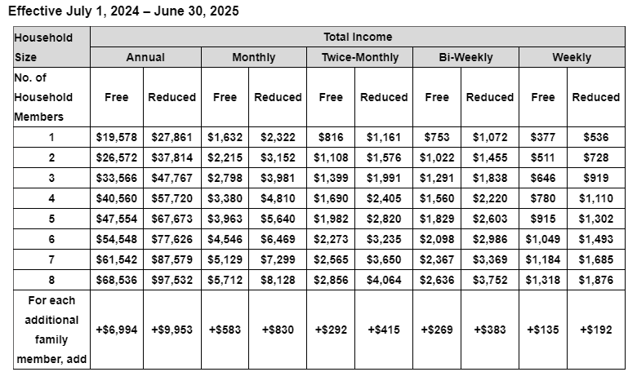
Annual Income Conversion: Weekly X52; Every 2 weeks X26; Twice a month X24; Monthly X12)

